## **Assignment II: Survey Form Revisited**

* Mandatory
* Deadline: Thursday of Week 1
* Difficulty Level: Basic
* Estimated Time: 1-2 hrs

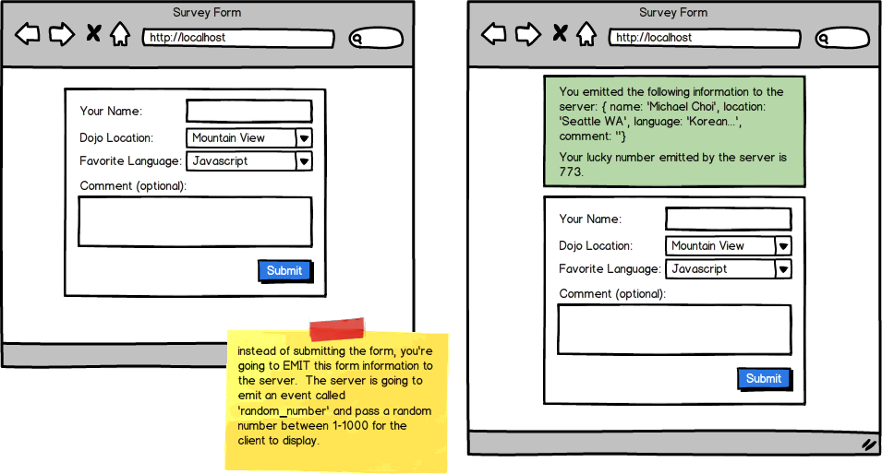

Before you start coding this, first outline or write down the steps of accomplishing this. Do this for EVERY nodeJS exercise as doing these steps will help you build your app easily.

For example for this particular app,

1. Have the server render views/index.ejs that has the form for the user to fill out
2. The user fills out the form and submits
3. The form information is EMITTED to the server with the event name "posting_form"
4. The server listens for an event 'posting_form' and when this event gets triggered, organizes all the emitted information to form a single message and sends this single message with the event called 'updated_message'. It also EMITs an event called *'random_number' with random number between 1-1000*.
5. The client listens for an event called 'random_number' and when this event gets triggered, shows the number in the HTML.
6. The client listens for an event called 'updated_message' and when this event gets triggered, displays the message somewhere in the HTML

Outlining these steps BEFORE YOU CODE, will make it so much easier to build your app. Again, there's not just one right way to build your app as you could build the same app using different steps but outlining what you plan to do first will increase your efficiency.

Top of Form

* Modify the previous assignment so that instead of doing a POST, it EMITs the form to the server under the the event name 'posting_form'. Have the server EMIT information back to the client and also emit another event called 'random_number' where the server gives a random number between 1-1000 to the client. Have the client display this lucky number. This app should work without having to do any POST or Redirect.

Bottom of Form